Linear Programming using LINDO

An example: Sherwood Furniture Company
Recently Sherwood Furniture Company has been interested in developing a new line of stereo speaker cabinets. In the coming month, Sherwood expects to have excess capacity in its Assembly and Finishing departments and would like to experiment with three new models. One model is the Standard, a large, high quality cabinet in traditional design that can be sold in virtually unlimited quantities to several manufacturers of audio equipment. Another is the Custom, a small, inexpensive cabinet in a novel design that a single buyer will purchase on an exclusive basis. The third model is known as the Portable. Under the tentative terms of this agreement, the buyer will purchase as many Customs as Sherwood produces, up to 32 units. The Standard requires 4 hours in the Assembly Department and 8 hours in the Finishing Department, and each unit contributes $20 to gross profit. The Custom requires 3 hours in Assembly and 2 hours in Finishing, and each unit contributes $10 to profit. The Portable requires 5 hours of Assembly time, 6 hours of Finishing time and each unit contributes $18 to profit. Current plans call for 120 hours to be available next month in Assembly and 160 hours in Finishing for cabinet production, and Sherwood desires to allocate this capacity in the most economical way.

The problem facing Sherwood Furniture is one of determining the quantity of each model to produce so that the capacity constraints in Assembly and Finishing are satisfied and the limit on the output of Custom models is satisfied in order to maximise the contribution to profit. These quantities are the decision variables in the problem.

A more formal description of the problem might be

maximise total profit contribution

subject to:
assembly hours allocated ≤ assembly hours available
finishing hours allocated ≤ finishing hours available
custom models produced ≤ market ceiling

In order to formulate this as a linear programme, we must first define the variables.

Let STD denote the number of Standards to be produced,
let CUS denote the number of Customs to be produced,
let POR denote the number of Portables to be produced.

Maximise f = 20STD + 10CUS + 18POR

subject to
4STD + 3CUS + 5POR ≤ 120 (Assembly Constraint)
8STD + 2CUS + 6POR ≤ 160 (Finishing Constraint)
CUS ≤ 32 (Market constraint)
STD ≥ 0, CUS ≥ 0, POR ≥ 0.

GETTING STARTED

Although there is a version of LINDO available on the unix system, the most convenient version to use is LINDO for WINDOWS which is installed on PCs in the Management School. After logging on, select Start → Programs → Misc (or Applications) → Lindo.

You will be presented with the Lindo window containing a new blank model window as shown below.

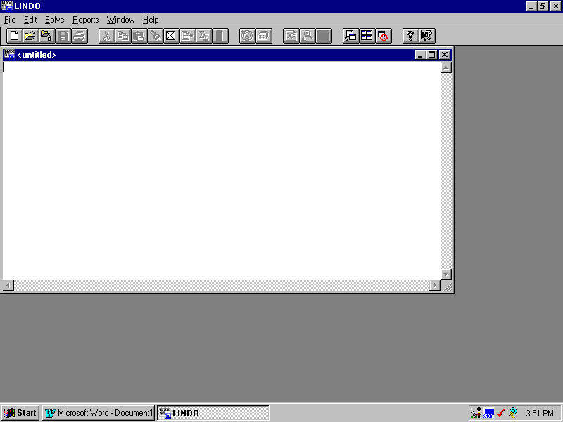

At any stage you can get assistance and more information about using Lindo by using the Help option on the main menu.

ENTERING THE FORMULATION

The formulation may be typed in to the model window as follows:

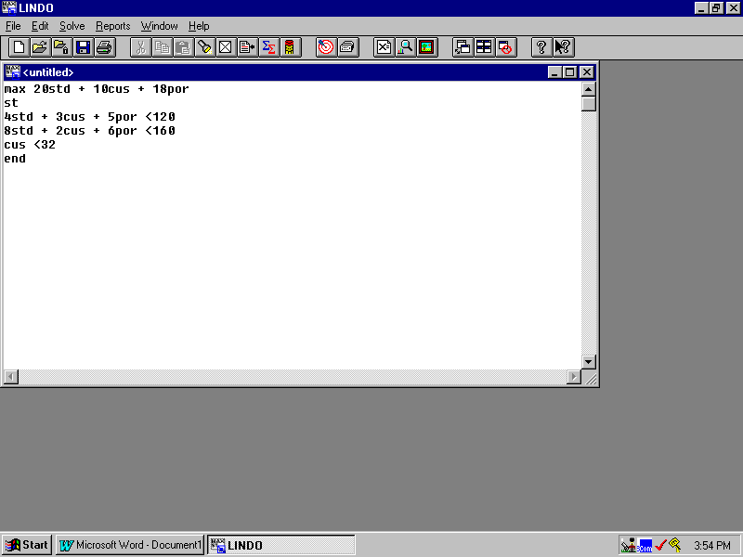

The first line must start with MAX (for maximisation problems) or MIN (for minimisation problems). If your objective line is very long, you can split it up into several lines if you wish. Lindo does not distinguish between upper and lower case letters; whatever you type in, Lindo will output upper case letters.

After the objective line, the letters “ST” represent “SUBJECT TO” (which you can type in full if you wish) and the following lines represent the constraints (one per line). As there are not keys on the keyboard for ≤ or ≥, the < is interpreted as ≤ and > is interpreted as ≥. The final line contains “END” to indicate that all the constraints have been specified.

Like most linear programming software packages, Lindo will assume that ALL THE VARIABLES ARE NON_NEGATIVE. These constraints should not be entered separately.

SOLVING THE MODEL

After you have entered the formulation, the model is ready to be solved. Select the Solve command from the Solve menu or press the Solve button on the toolbar at the top of the window. (It’s the one with an arrow hitting a target.) Lindo will begin by trying to compile the model. If your model cannot be interpreted by Lindo you will get an error message and Lindo will jump to the line where the error occurred. You should then examine your model for any errors and correct them.

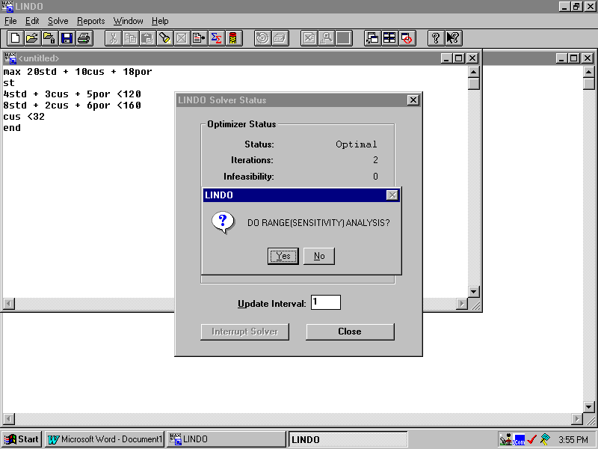
If there are no compilation errors, Lindo will attempt to solve your model and will display a Status Window on the screen. When the solver is finished, you are given the option for a sensitivity and range analysis. Normally you will want to select “Yes”.

Lindo creates a new window on the screen titled “Reports Window”. The Reports Window contains the output from solution and the results of the sensitivity analysis. It should look like the following (though note that there is only room for the first part of the sensitivity analysis to be shown on the screen; scroll down to see it all.)

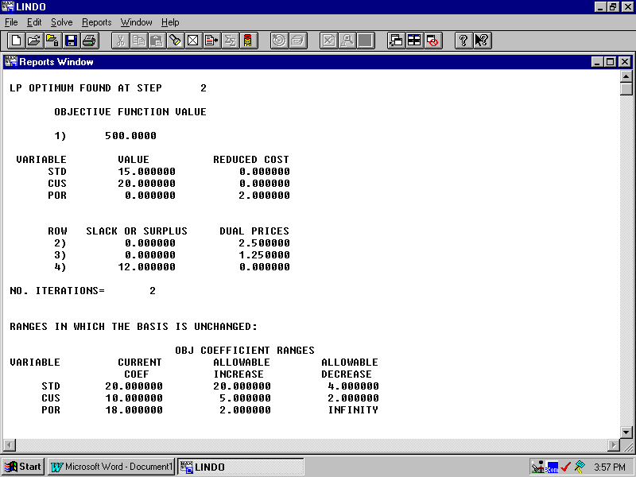
Note that Lindo has labelled the objective as row 1) and then the constraint rows are numbered beginning with the first constraint as row 2).

You can select and copy the results into a word processing document in the usual way. However remember that when you have pasted the results into your document you should use a constant width font (such as Courier New) to preserve the column alignments.

The full results and sensitivity analysis are as follows:

LP OPTIMUM FOUND AT STEP 2

OBJECTIVE FUNCTION VALUE

1) 500.0000

VARIABLE VALUE REDUCED COST
STD 15.000000 0.000000
CUS 20.000000 0.000000
POR 0.000000 2.000000

ROW SLACK OR SURPLUS DUAL PRICES
2) 0.000000 2.500000
3) 0.000000 1.250000
4) 12.000000 0.000000

NO. ITERATIONS= 2

RANGES IN WHICH THE BASIS IS UNCHANGED:

OBJ COEFFICIENT RANGES
VARIABLE CURRENT ALLOWABLE ALLOWABLE
COEF INCREASE DECREASE
STD 20.000000 20.000000 4.000000
CUS 10.000000 5.000000 2.000000
POR 18.000000 2.000000 INFINITY

RIGHTHAND SIDE RANGES
ROW CURRENT ALLOWABLE ALLOWABLE
RHS INCREASE DECREASE
2 120.000000 24.000000 40.000000
3 160.000000 80.000000 48.000000
4 32.000000 INFINITY 12.000000

It is sometimes helpful to get a copy of your model formulation which has been tidied up by Lindo and which has the rows labelled. Once your model has been compiled you can do this by selecting the Reports Menu and the Formulation option. Your model is then printed out in the reports window. You can select it and paste it into a word processor document. Alternatively, you can select the command window and type the command “LOOK ALL” and have the same output in the command window.

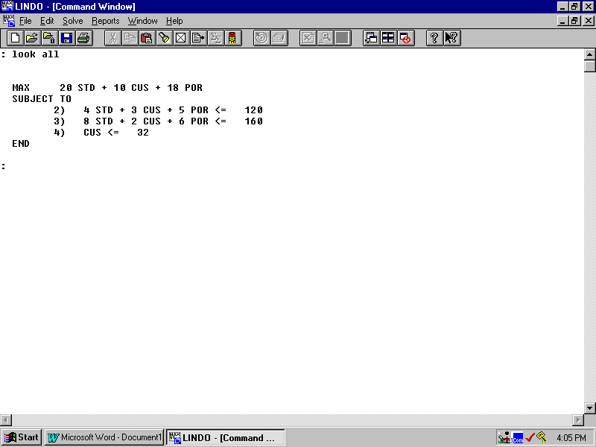
THE SIMPLEX TABLEAU

If you wish to see a copy of the Simplex tableau, then from the Reports menu select Tableau and a copy of the tableau appears in the reports window.

In fact it is possible to use the Tableau command in conjunction with the pivot command to see the Simplex tableau at each iteration if you wish to do so. However you should be aware that Lindo uses a different heuristic to the one taught in the lectures for deciding which variable to bring into the basis at each iteration. Therefore the iterations may be different to what you expect, although the final solution and tableau should always be the same.

When Lindo needs to introduce a slack variable for row n, it gives it the name SLK n.

There are a few differences to note when interpreting the Lindo Simplex tableau to the convention which has been used in the lectures:
i) The objective row is the first row labelled 1 instead of coming after the constraints. It is also confusingly labelled “ART”.
ii) The last row of the first tableau is labelled “ART ART” and contains the artificial objective. This is printed even if no artificial variables are required for an intial basic feasible solution. If artificial variables have been introduced, then once Phase 1 of the Simplex algorithm is complete and the artificial objective has been reduced to zero, then this row (and columns corresponding to any artificial variables) is ignored by the algorithm in Phase 2.

Also note that if the page is not wide enough for all the columns, then the tableau is printed in sections with the row labels repeated until the final RHS column is reached.

For this example, the final tableau is as follows:

THE TABLEAU

ROW (BASIS) STD CUS POR SLK 2 SLK 3
1 ART 0.000 0.000 2.000 2.500 1.250
2 CUS 0.000 1.000 1.000 0.500 -0.250
3 STD 1.000 0.000 0.500 -0.125 0.188
4 SLK 4 0.000 0.000 -1.000 -0.500 0.250
ART ART 0.000 0.000 2.000 2.500 1.250

ROW SLK 4
1 0.000 500.000
2 0.000 20.000
3 0.000 15.000
4 1.000 12.000
ART 0.000 0.000

OTHER OPERATIONS

Lindo has many other operations which you can explore with the assistance of the Help option. For example, you can save a model which you have created in the usual way using the save option on the File menu. Remember that this only saves the model and you will need to solve it again to get the output unless you have already copied the contents of the results window to a file which you have saved.

FURTHER HELP

You can obtain further help on Lindo from their website:

http://www.lindo.com

If you want a copy of Lindo for your own PC, it is possible to download a free version which can solve small problems from this website.

